**AR Office Weather with Magic Leap One, Ruuvis and ConNXT**

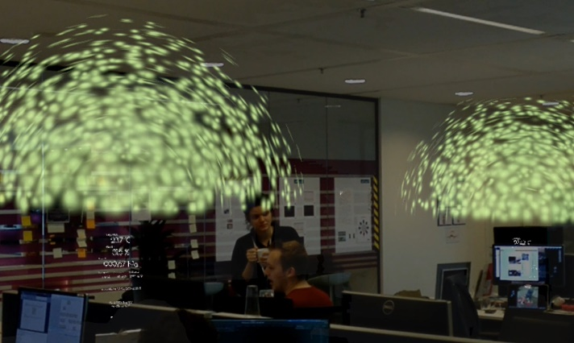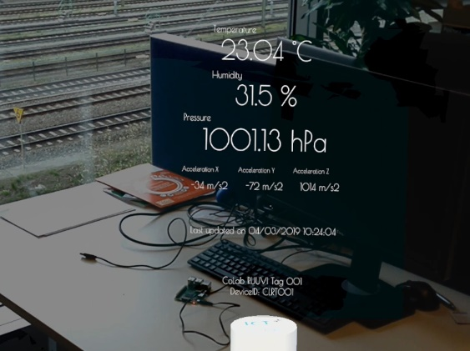

We created an app that displays the weather inside an office or a closed space in the form of AR experience. We use RUUVI tags sensors to collect the telemetry data from different spaces in the office, send the data to an IoT hub, then receive the data on the Magic Leap and adjust the user experience accordingly.

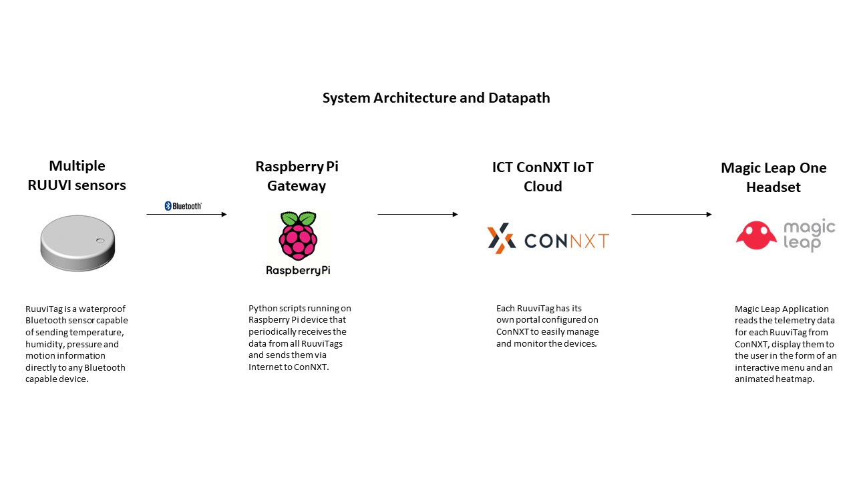

**For video demos please go to the links by scanning the following QR codes:**



